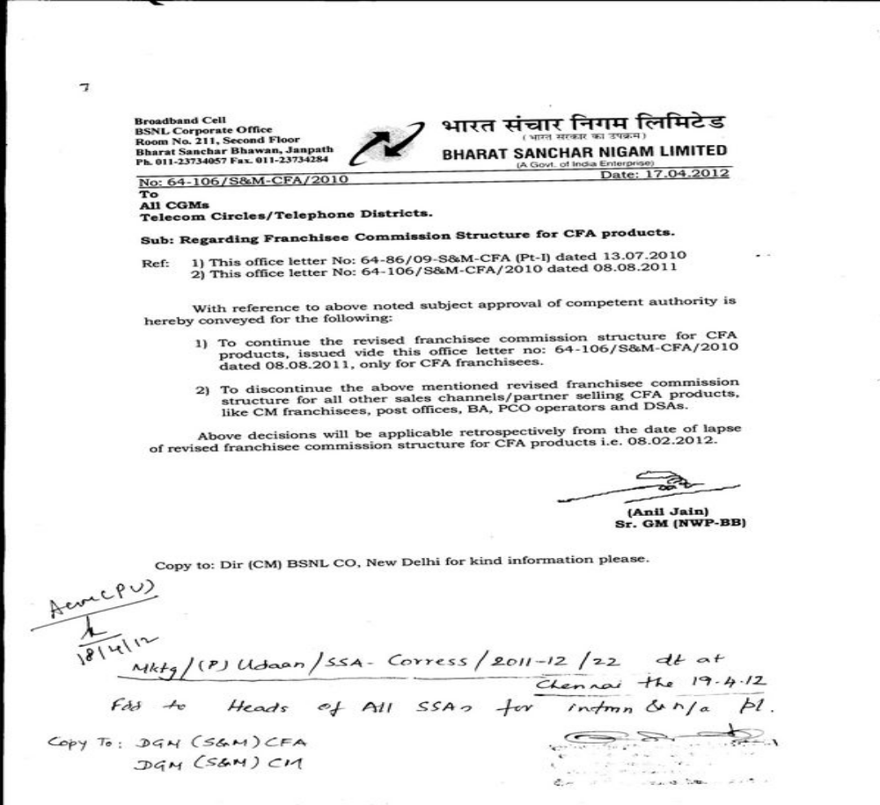


1 Click here for Ref. Lr. 1
2 Click here for Ref. Lr. 2

