Bharat sanchar nigam limited
Product Manual for Employees
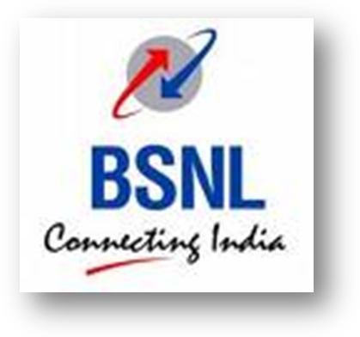

Wireline Intelligent Network Services
Compiled and Prepared by: Sanjay Kumar, DGM (NWO-II/CFA), BSNL, Corp. Office

(For Internal Circulation Only)

Dear Colleagues,
During the last few years all the Telecom Services Providers including BSNL have started giving increased focus on Enterprise Customers segment due to falling ARPU from retail services. BSNL is also facing continues decline in its revenue from Fixed Access Services. The challenge of BSNL is basically on executing the best strategy in order to arrest the drop in fixed line business.
The changed scenario requires us to realign our strategy and change our business model. Under the changed requirement all of us should give more focus on services catering to diverse requirements of Commercial Customers. BSNL Fixed IN Services can be a big opportunity for us to increase our revenue from Fixed Access.
Presently there are 5 IN platforms and we have 10 services namely- VCC, ACC, FPH, Voice VPN, PRM, UAN, Televote, UPN, and FLPP. On the new IN platforms we have huge capacity for various IN services, for example, one GPIN is capable of providing 1.5 crores ITC, 5 lakh ACC and UPN, 9000 customers for each of FPH, PRM, VPN and 12,500 customers for UAN. However, it is seen that there is a lot of scope to increase the customer base. Similarly, the Mass Calling IN Platform has also been upgraded.
BSNL has also signed agreement for inter-operability of FPH and UAN with almost all private operators. At present BSNL is in a unique position as the only operator to have signed such agreements with most of the other operators. It is expected that BD officials should be able to market these services by making it as the Unique Selling Point (USP) and take advantage of this situation before the competition catches up. VPN is another killer application which can help us in arresting the surrender of landlines especially from high paying customers. Housing Societies are big market for VPN services.
Director (CFA) has desired to increase the revenue from the IN services. Having commissioned the IN platforms of such huge capacity, it should be our endeavor to utilize the capacity and garner a bigger market share for BSNL.
One of the major concerns is lack of awareness among us regarding Fixed IN Services. The very purpose of preparing this manual is to disseminate information regarding various IN services being offered by BSNL and I am sure that this manual will help you in this.
I invite your suggestions for improving the revenue from IN services. Also feel free to clarify your doubt, if any. Our staff will be glad to help you in any manner.
With best regards,
(Hari Ram Shukla)
GM (NWO-CFA), Corp. Off.

INDEX
Sr. No. | Sub-Item | Page no.
1 | An Introduction | 1
2 | Basic Concepts | 1
3 | IN Network Architecture | 4
4 | Technical Details | 5
5 | BSNL IN Services | 6
6 | Toll Free Service | 7
7 | Universal Access Number(UAN) | 11
8 | Virtual Private Number(VPN) | 12
9 | Televoting Service(TELVOT) | 20
10 | Universal Personal Number | 23
11 | Account Calling Card(ACC) | 27
12 | Premium Rate Service(PRM) | 28
13 | Virtual Calling Card (VCC) | 29
14 | Fixed Line Pre Paid(FLPP) | 30
15 | IN Access Codes | 31

An Introduction
The term Intelligent Networks (IN) is used to describe an architectural concept which is intended to be applicable to all telecommunications networks and aims to ease the introduction and management of new services. The objective of IN is to allow the inclusion of additional capabilities to facilitate provisioning of service, independent of the exiting network capabilities. There are many new services implementation of which requires substantial changes in the existing switches belonging to different vendors. It not only very time consuming but often uneconomical too. Now, with IN technology it is possible to introduce new services rapidly without affecting the available services.
The IN’s main advantage is the ability to control switching and service execution from a small set of Intelligent Network nodes known as Service Control Points (SCP).These SCPs are though very few in numbers (four in BSNL network) but can control thousands of switches.

Basic Concepts

Need for IN
In the past few years the development of telecommunications networks has been rapid. User demands for more sophisticated telecommunications services in shortest possible time. Today’s telecommunication networks consist of equipments from multiple vendors who uses their own propriety technology, making it very difficult and time consuming to implement any new service which require changes in multiple switches. New Software patches are to be developed for each type of technology switches and loaded in each switch to implement the new service.
The goal of IN is to provide network operators with the ability to introduce, control and manage services more effectively by using a centralized database in a Service Control Point (SCP) for controlling and managing the various network services. That is, intelligence is taken out of the switch and placed in computer nodes i.e. SCPs. The objective of IN is to allow the inclusion of additional capabilities to facilitate provisioning of service, and facilitates the provisioning of services independently from the telecommunications networks and equipment vendors. So, the IN acts as a centralized framework for telecommunications services. With this framework, it is possible to introduce advanced customer oriented services rapidly and cost effectively.

Why it is called Intelligent?

An intelligent network (IN) is a service-independent telecommunications network. That is, intelligence is taken out of the switch and placed in computer nodes that i.e. SCP. So to implement a IN service, intelligence of the switch with which the customer (sending the request for an IN service by dialling) is connected, is not used. Switches simply forward the requests of customers for IN services to concerned IN node i.e. SCP. It is this SCP which uses its intelligence and directs the requesting node to take particular action. Forwarding switches simply obey the orders of their IN nodes. As SCPs are servers based implementation of an advanced service is much easier.

How it is different from Basic Services?
Non-IN or Basic services uses distributed intelligence and switching capabilities of Basic switches(such as OCB283,EWSD,AXE,5ESS etc) whereas IN services uses the intelligence of IN platform i.e. SCP.

Why are the advantages of deploying IN Services?
The main benefit of intelligent networks is the ability to improve existing services and develop new sources of revenue. To meet these objectives, providers require the ability to accomplish the following:
- Introduce new services rapidly— IN provides the capability to provision new services or modify existing services throughout the network with physical intervention.
- Provide service customization—Service providers require the ability to change the service logic rapidly and efficiently. Customers are also demanding control of their own services to meet their individual needs.
- Establish vendor independence—A major criterion for service providers is that the software must be developed quickly and inexpensively.
- Create open interfaces—Open interfaces allow service providers to introduce network elements quickly for individualized customer services. The software must interface with other vendors' products while still maintaining stringent network operations standards. Service providers are no longer relying on one or two vendors to provide equipment and software to meet customer requirements.

How it Works?
Intelligent Network provides a framework to create various services in a centralized place independent of the switch. In IN, calls generated by a subscribers are routed to the nearest IN systems by the concerned exchange, on high speed links to get the necessary information and commands for further routing of the call. IN Services can be used by subscriber connected to any type of exchange using existing telephones.
In nutshell IN platform act as a Master Brain for underlying Fixed Landline and Mobile network. The underline networks simply execute the command receiver from IN systems. A user of IN service not only benefits from the newer capabilities of centralized IN platform but also continue to enjoy the reach of exiting fixed and mobile network.
As IN platform doesn’t directly interact with user, there is no need to buy the new devices to enjoy the additional capabilities of IN platform. SCPs are connected to the network switches (known as Service Switching Points) via a standardized interface; CCITT Signalling System No. 7. In our network existing new technology Basic switches ( OCB283,EWSD and 5ESS) has been upgraded to perform SSP functionality. Other switches like C-DOT,AXE,E10B works in overlay mode i.e. they simply forward the IN call to next SSP capable switch.
Based on the dialled digits, by caller, (e.g. 1800 for toll free service) SSPs detect when the SCP should handle a service. The SSP forwards a standardized SS7 message containing relevant service information. The service control logic in the SCP directs the SSPs to perform the individual functions e.g. in case of Toll Free Service, SCP direct SSP to dial another number which may be a number of a call centre. Hence though a caller dials 1800 number, calls terminate on a different number. Selection of this new number may be based on number of criteria e.g. CLIP of the calling number, Time and day of the call etc defined in the SCP. If any changes is to be made in the selection criteria change has to be made in only one place i.e. SCP.

IN Network Architecture
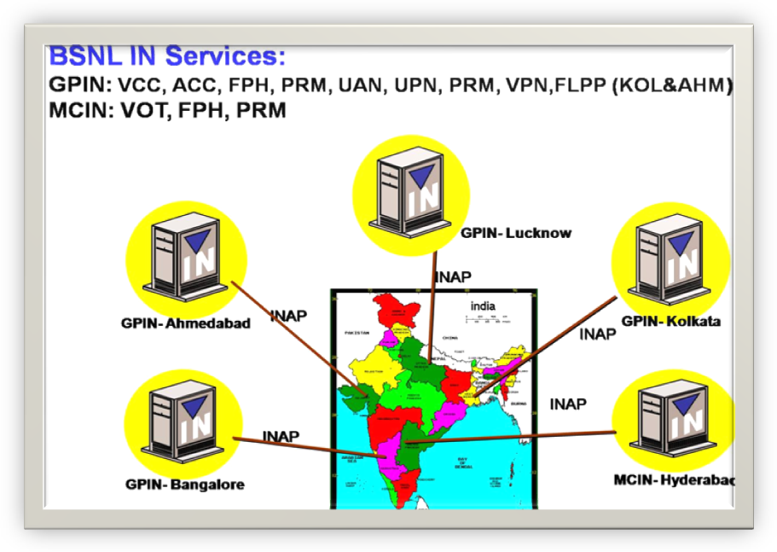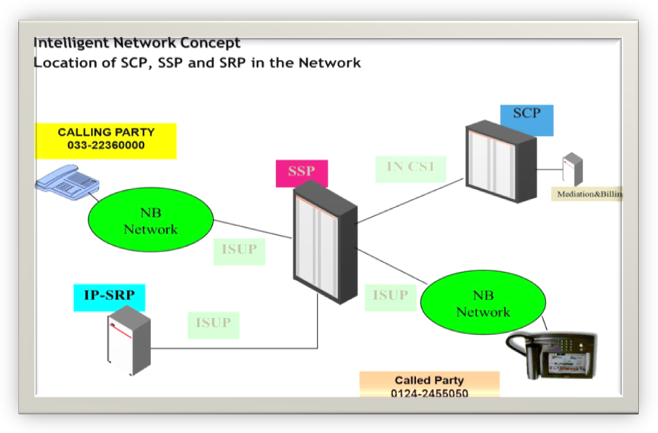

Technical Details

Terminology
Service user The service user is the person who invokes the service..
Service operator Entity that owns the IN-platform and provides the IN service and manages the IN platform.
SAC The service access code is the digits string to be dialled by the service user to access to the service.

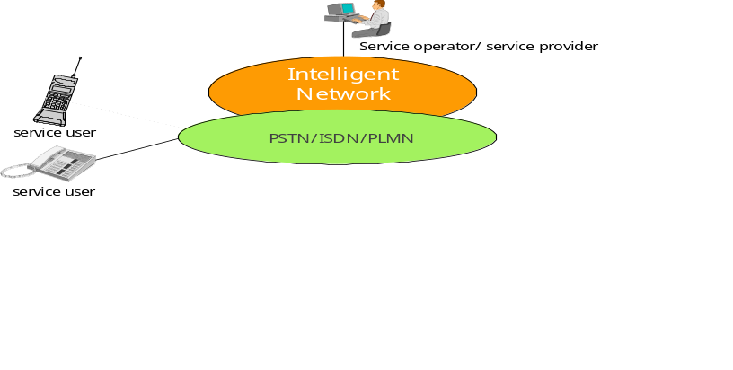

Network Elements of IN Platform
SCP: Service Control Point
SSP: Service Switching Point
SRP: Service Resource Point
SMP: Service Management Point

BSNL IN SERVICES
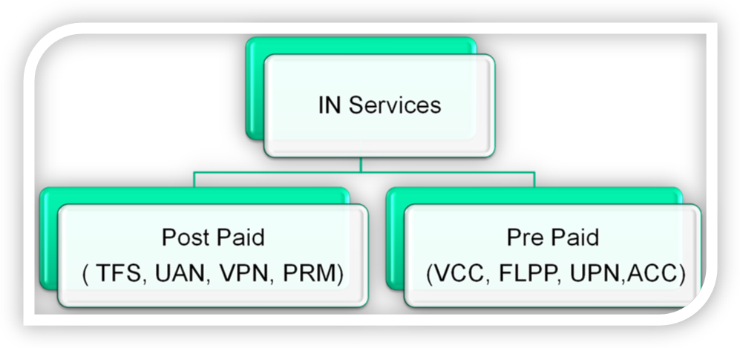
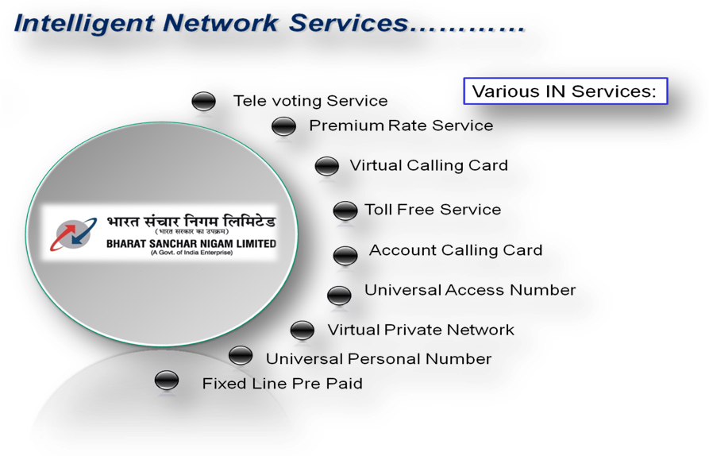

Toll Free/Free Phone Service

What is Toll Free phone service?
This service uses the new function in charging, a call to a service subscriber is paid by the called party. All charges are levied on the service subscriber. For the calling user the service is free of charge. Ideal for hotels and the whole business community in general who want their customer to call them free of cost. Also known as the “Free Phone Service” this service is ideal for customer oriented organizations that can provide information about their products, allow customer to place orders and even register complaints. They need to advertise only one logical number which is accessible from all over India (BSNL/ MTNL /private telecom operators).
• 11 digit number 1800-XYZ-ABCD
How it Works?
Callers dial the 11 digit TFS number. This number is analysed in the IN system. One can define upto 8 Fixed or Mobile numbers against the TFS number. IN system translate the TFS number to the attached fixed or Mobile number and route the call as per pre-defined criteria.
Who can subscribe for Toll Free phone service?
• Enterprises or organizations with large customer base or having call centers.
• Retail products and services Industry.
• Ideal for hotels and restaurants.
• Companies providing after sales support as customers associate a Free phone number with the quality of the business products or services
• Whole business community in general .Convenient for the subscriber who has multiple offices in multiple cities or localities. The subscriber can retain the TFS number even after the office location changes. Thus this service is an ideal business promotion tool for business communities who want their customers to call them without any hassle.
What BSNL Offers to Toll Free Phone subscribers?
Our advanced features offers a bundled solution that can help business organization track calls, route calls based on customer’s organization's needs, and safeguard their traffic against long-term service interruptions. Moreover these also help in reducing their overall expenditure significantly on Customer Support Services.
Single All India Number - A single 11 digit number accessible throughout India including other operator’s network. No STD facility required to access the service. Multiple Call Centres can operate and handle the customer calls based on user defined criteria such geographical location, time of the call, day of the call etc.
Other Features: In addition to the basic functionality i.e. Single All India Number and Reverse Charging there are host of add on features available that not only revolutionizes the traditional methods of interacting with customers but also helps in optimizing the cost of providing customer support.
Time dependant Routing (TDR) - allows organizations to route the calls to different locations, depending on the time of day. For example, if a particular customer service department is closed at night, calls can be routed to alternate location. This helps the business organisations in maintaining 24x7 customer supports with minimal investment.
Day of the Week Routing –Calls can be routed not only as per the Time of the day but also as per the type of day.
Origin Dependent Routing - Calls can be routed to set of destinations based on the location of the origin of the call i.e. Call Centres can be established on Zone Basis.
NUMBER TRANSLATION AND ROUTING SERVICES - Example
In this example, the users can reach a commercial entity physically distributed in three sites by dialing a single telephone number (800 12345) from a fixed or mobile telephone set.
The commercial entity is distributed as follows:
One main agency,
Two secondary agencies.
The commercial entity being a number translation and routing service subscriber has defined time distribution criteria enabling to reach:
The main agency from 09H to 12H,
The secondary agency 1 from 12H to 14H,
The secondary agency 2 from 14H to 09H.
The service data enable the relationship between the called number and the time criteria. They are used by the service logic during a call handling to this number.
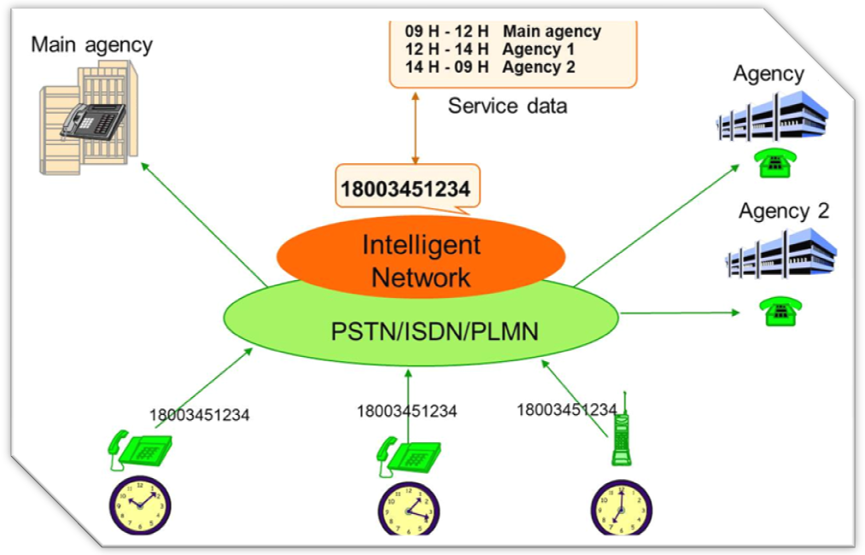
Call distribution - allows the organization to route calls based on staffing levels. The call split is based on a percentage distribution that user designate. If a user has three Call centres having the Staff strength of 20, 30 and 50 calls can be routed to these Call Centres in ration of 2:3:5 i.e. out of ten calls, two, calls will routed to first Call canters, three to second call centres and five to third call Centre.
Line hunting – allows organization to have one or more installations where the call may be answered i.e. a user can have multiple call centres (up to eight) anywhere in India. All Call Centre numbers can be put under a hunting group
Call limiter – Restricts maximum number of simultaneous calls and this helps organization to dimension resources.
Call Queuing – enables calls meeting busy condition or reaching call limiter to be placed in a queue and as soon as free condition is detected the call is answered
Condition based routing - Calls at the destination can be re-routed to a different destination number in following conditions (1) Busy (2) No Answer (3) Reached call limiter.
Interactive voice RESPONSE: The IVR routes calls to the appropriate person or department based on keypad inputs selected from the menu options as defined by the service subscriber e.g. if a business organisation has three different product division handling three different products such as Desktop, Netbook and printers than a customer will be asked to dial 0 for desktop, 1 for Netbook and 2 for Printers and calls are routed based on user input.
Black & White List - allows organization to selectively block incoming calls from specific originating areas. In this way, one can shape your area of coverage to match your requirements and also save on the cost of handling unnecessary calls.
Incoming Grey list - When a calling line is added in the grey list , a PIN is associated with it. When a caller from grey list access the service, a PIN is asked for authentication.
Detailed Bill - Details of calls received is provided. This helps organization in marketing and business planning.
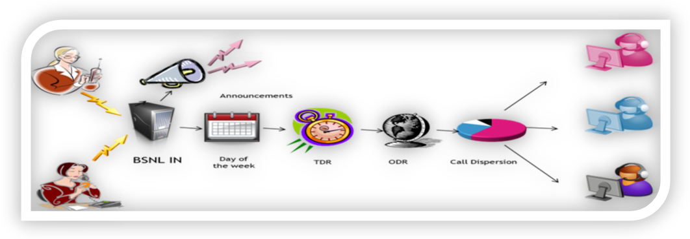

Universal Access Number
• There are two types of UAN services, UAN Full Charge and UAN split Charge
- In UAN full charge full call charges are paid by callers whereas in UAN split charge callers pay the local calls and STD charges are paid by Called Party.

- Service is accessible from networks of other Operators also

- 11 digit number 1860-XYZ-ABCD

How it Works?
- Same as TFS.

Virtual Private Network
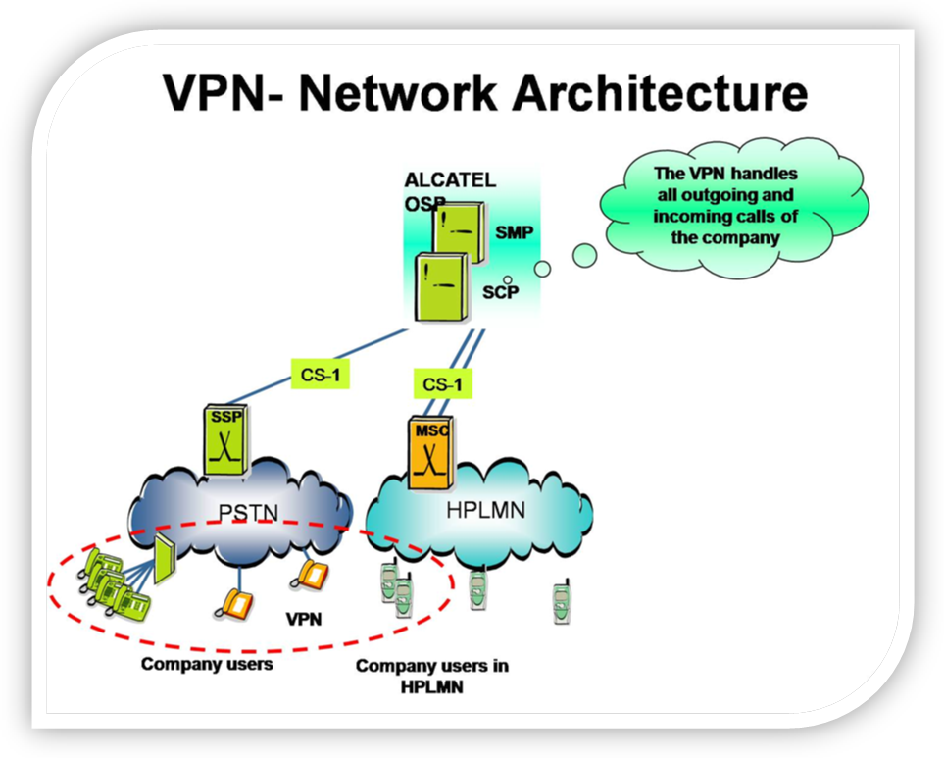
Voice VPN is a service for providing a private network for institutions, businesses and communities using public network resources. The subscriber’s lines, connected to different network switches, constitute a virtual PABX. The nos. within VPN can be assessed either by dialing # followed by a short code (pnp).
The VPN service works on the public networks providing a private numbering plan, a private access to multiple locations and company call control. The VPN service handles outgoing and incoming calls of mobile and fixed company users in the subscribing company’s environment:
Inside the company,
From the company to outside,
From the outside to the company.
The VPN service is implemented on the following network interfaces:
How it is different from CENTREX and EPABX?
EPBAX allows customers to terminate large number of extensions at the same location by having smaller number of Direct Exchange Lines from Telco’s, whereas CENTREX is central office based communication service which integrates all multi located Telephone lines (Existing and New) into a single highly functional communication group (read Virtual EPBAX) with more distinctive features and without any additional equipment (like EXABX) at the premises. Both of the solutions have their own limitations such as both the solutions don’t support mix of fixed and mobile lines and their capabilities are limited by the capabilities of Landline/Mobile switches with which these are connected with.
On the other hand Combined voice VPN can be provided for fixed line telephones as well as mobile with no geographical limitation(with in India) and also its capabilities and features are not limited by connected switching nodes.
Is it possible to create a single VPN for telephone numbers located at different physical sites?
Yes, VPN Service can bring telephones at different sites located at different physical location anywhere in India under one single Network.
What is VPN Call?
All calls made within VPN Group are VPN Calls and are termed as ‘ON NET’ calls. These calls are billed according to VPN Tariff plan which is different from normal tariff.
What is the dialling plan for VPN calls?
All the VPN Calls are made by dialing #PNP or in some cases by dialing Service Access Code 1801 XYZ followed by PNP. BSNL unit at the time of registration shall inform you about the dialing procedure from each number.
What is PNP?
PNP stands for Private Numbering Plan. Your telephone numbers which have to be in a VPN are given a 3 or 4 digit short code for ease of dialing, which is called PNP number.
Can a short code be given to other telephone numbers which are not part of VPN.
Yes, public directory numbers which are not part of VPN Network can be given a short code which is defined at Company level. It provides ease of dialing for the numbers which are frequently dialed but the billing for such calls shall be as per normal tariff.
Can BSNL provide department -wise bills?
Yes, VPN Service allows the company users of a given VPN group to mark their calls according to business so that subscribing companies receive a bill, which details the cost of communication according to the company activities and the company organization. You should request for this facility at the time of registration.
Does VPN Service provide Call forwarding feature?
Yes, call forwarding feature is provided in VPN Service. Calls coming to one VPN number i.e. pnp can be forwarded to another pnp.
How to make calls outside VPN?
Non-VPN calls can be made by directly dialing the destination number i.e. dialing the destination number by prefixing STD Code/ 95/ or local number. These calls are billed by local exchange against the local number as per prevailing tariff and indicated in the local telephone bill in the normal way.
Can the business and personal calls of a VPN Member be separated?
Yes, a dual invoicing ability is there which can be used to bill calls made by a given company member either on the corporate account or on the VPN member personal account.
What are other attractive features of VPN Service?
- Date & Time Screening – The calls can be routed to a particular destination number or announcement depending on date and time at which call are made.
- Hunting List – A series of numbers may be defined in hunting list for incoming calls per pnp so that call comes to first number and in case of busy/ no reply it goes to next number in hunting list.Maximum 10 such numbers can be provided in hunting list.
- Preferred External Destination (PED) - If there exists a number, which is not a part of VPN Network but is frequently called then it can be defined as PED in the network at a particular site viz. number of food outlet at a local site. It will make the dialing of such frequently dialed numbers very easy.
What is the difference between Short Code and Preferred External Destination?
Short Code are defined at company level and Preferred External Destination are defined at site level charging for both type of calls is different from VPN Calls. Normal tariff is charged for these type of calls. Therefore short code is like PED which is common to all sites.
What types of VPNs are available in BSNL Network?
Presently there are two types of VPNs
- Circle VPN – The VPN group constitutes telephone numbers of one circle only.
- All India VPN - VPN group constitutes of telephone numbers across
FAQs on Voice VPN
- What is Voice Virtual Private Network (VoiceVPN) Service?
Voice VPN is a service for providing a private network for institutions, businesses and communities using public network resources. The subscriber’s lines, connected to different network switches, constitute a virtual PABX. The nos. within VPN can be assessed either by dialing # followed by a short code (pnp) or by dialing Service Access Code and pnp depending upon the type of exchange you are connected to.
- Who should take Voice VPN Service?
Voice VPN Service has been designed specifically for business communities who have their Offices situated at different physical locations and need to make frequent and long duration intra-organization calls. If calls are made through VPN Service you will have to pay smaller amount as compared to the normal (local or long distance) tariff.
- Why should I take Voice VPN Service?
With Voice VPN Service dialing becomes simple as you need to dial only few digits to make calls and call charges are also cheaper as compared to normal tariff. Additional benefits of Voice VPN Service are.
Prevents unauthorized STD usage and abuse
- Improves security and cost control
- Abbreviated dialing give users shorter numbers to memorize
- Workload can be distributed between teams located at different site without bothering about cost of Communication.

- Is it possible to create a single VPN for telephone numbers located at different physical sites?
Yes, VPN Service can bring telephones at different sites located at different physical location anywhere in India under one single Network.
- How can I get Voice VPN Service?
In order to subscribe to VPN Service all you need to do is visit the link http://www.bsnl.co.in/forms/in_form/vpn_form.htm to download the Voice VPN Service form. Then fill up the form after reading the instructions given in the form and submit it at your nearest BSNL Office.
- What is VPN Call?
All calls made within VPN Group are VPN Calls and are termed as ‘ON NET’ calls. These calls are billed according to VPN Tariff plan which is different from normal tariff.
- What is the dialing plan for VPN calls?
All the VPN Calls are made by dialing #PNP or in some cases by dialing Service Access Code 1801 XYZ followed by PNP. BSNL unit at the time of registration shall inform you about the dialing procedure from each number.
- What is the Service Access Code for Voice VPN?
The service access code for Voice VPN is 1801 XYZ (XYZ = 345-for Kolkata/425- for Bangalore/180-for Lucknow/233- for Ahmedabad. You will be informed about it by concerned BSNL unit at the time of subscription.
- What is PNP?
PNP stands for Private Numbering Plan. Your telephone numbers which have to be in a VPN are given a 3 or 4 digit short code for ease of dialing, which is called PNP number.
- Can a shortcode be given to other telephone numbers which are not part of VPN.
Yes,public directory numbers which are not part of VPN Network can be given a short code which is defined at Company level. It provides ease of dialing for the numbers which are frequently dialed but the billing for such calls shall be as per normal tariff.
- Can BSNL provide department -wise bills?
Yes, VPN Service allows the company users of a given VPN group to mark their calls according to business so that subscribing companies receive a bill, which details the cost of communication according to the company activities and the company organization. You should request for this facility at the time of registration.
- Does VPN Service provide Call forwarding feature?
Yes, call forwarding feature is provided in VPN Service. Calls coming to one VPN number i.e. pnp can be forwarded to another pnp.
- How to make calls outside VPN?
Non-VPN calls can be made by directly dialing the destination number i.e. dialing the destination number by prefixing STD Code/ 95/ or local number. These calls are billed by local exchange against the local number as per prevailing tariff and indicated in the local telephone bill in the normal way.
- Can the business and personal calls of a VPN Member be separated?
Yes, a dual invoicing ability is there which can be used to bill calls made by a given company member either on the corporate account or on the VPN member personal account.
- What are other attractive features of VPN Service?
- Date & Time Screening – The calls can be routed to a particular destination number or announcement depending on date and time at which call are made.
- Hunting List – A series of numbers may be defined in hunting list for incoming calls per pnp so that call comes to first number and in case of busy/ no reply it goes to next number in hunting list.Maximum 10 such numbers can be provided in hunting list.
- Preferred External Destination (PED) - If there exists a number, which is not a part of VPN Network but is frequently called then it can be defined as PED in the network at a particular site viz. number of food outlet at a local site. It will make the dialing of such frequently dialed numbers very easy.

- What is the difference between Short Code and Preferred External Destination?
Short Code are defined at company level and Preferred External Destination are defined at site level charging for both type of calls is different from VPN Calls. Normal tariff is charged for these type of calls. Therefore short code is like PED which is common to all sites.
- What types of VPNs are available in BSNL Network?
Presently there are two types of VPNs
- Circle VPN – The VPN group constitutes telephone numbers of one circle only.
- All India VPN - VPN group constitutes of telephone numbers across the country

- What is the dialing plan for Voice VPN?
The dialing plan is given below in table 1.
Table1
Existing Dialing Plan | New Dialing Plan | Remarks
Using Service Access Codes (SAC)  - 1801-180-pnp for customers created from Lucknow SCP  - 1801-345-pnp for customers created from Kolkata SCP  - 1801-233-pnp for customers created from Amedabad SCP  - 1801-425-pnp for customers created from Bangalore SCP | No need to dial full SAC. Rather dial as follows:  #(new) pnp | SAC pnpdialing can also be used.
Using Directdialing of PNP | As above | As above
SAC dialingfrom lines from where short code dialing was not technically feasible | SAC pnp to be dialled | # dialing is not technically feasible. Such numbers are specifically indicated by BSNL in the pnp list.
From Mobile | #new pnp | -
From CDMA- Not available | - | -

- How many digits are there in a PNP except first digit which represents SCP Code?
The number of rest of the digits of PNP may vary as per the size of the individual VPN group.
- Whether I can get Voice VPN Service in offices located in MTNL areas of Delhi and Mumbai?
Yes, the Voice VPN facility can be extended to offices having fixed line numbers of MTNL Delhi and Mumbai also. The dialing procedure is same as for BSNL numbers.
- How the first digit of PNP has been fixed?
The country has been divided in four zones & in each zone can be on the SCP catering to all India numbers. First digit of PNP has been fixed as follows to indicate the SCP which when dialed will be replaced by digits as given below.
S. No. | SCP Location | First digit of PNP number | Digits after replacement
1 | Lucknow (180) | 1 | 1801
2 | Ahmedabad (233) | 2 | 2332
3 | Kolkata (345) | 3 | 3453
4 | Bangalore (425) | 4 | 4254

- How other digits of the PNP shall be assigned?
Rest of the digits of PNP shall be assigned by SCP staff at the time of configuring the VPN as are assigned today.
- From which exchanges the above dialing plan can be used?
This dialing plan can be used from telephone numbers belonging to new technology exchanges i.e. OCB-283, EWSD, 5ESS & Ericsson after suitable category is put on the concerned lines. From all other technology exchanges (viz. E-10B, C-DoT etc.) this short code dialing is not technically feasible and VPN numbers can be assessed by using Service Access Codes (SACs) only.
- What is the procedure for applying category on the line of customer in the NT exchanges available?
CTD has put the procedure of applying these categories on the telephones lines on its website for use and downloads by all exchange in-charges. For any query related to this SCP in-charge Kolkata may be contacted.

Televoting
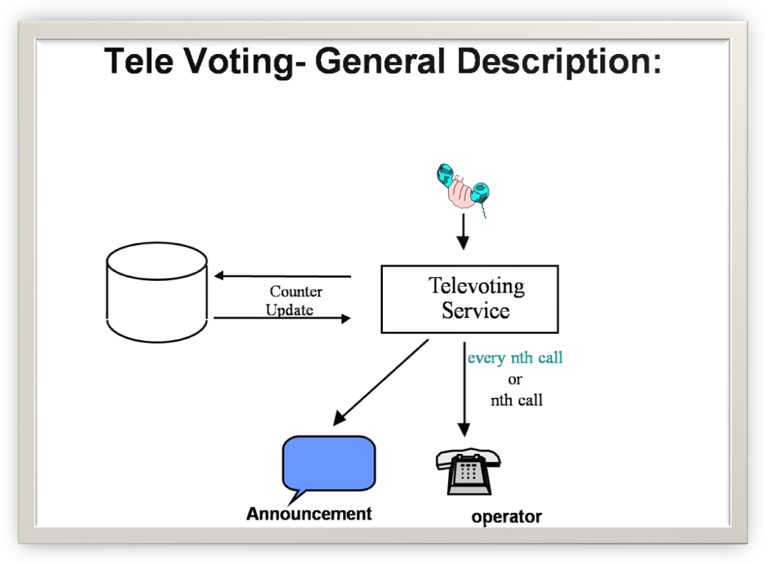
What is Televoting service?
Televoting or televote is the term used to describe the telephone voting in which broadcasters provide the audience with different telephone numbers associated with contestants participating and the outcome is decided by the number of calls to each line. Music contests such as the Eurovision Song Contest, as well as for World Idol, American Idol and similar use this method. Televoting is the sole voting avenue in the Eurovision. From 1997, the European Broadcasting Union, organiser of the Eurovision Song Contest, introduced telephonic and SMS voting for competing entries in place of national juries. This way the voice of the television audience became crucial to choose the winning song. Reality television contests around the world such as Big Brother can use televoting to choose a winner or to eliminate a contestant from thse contest.

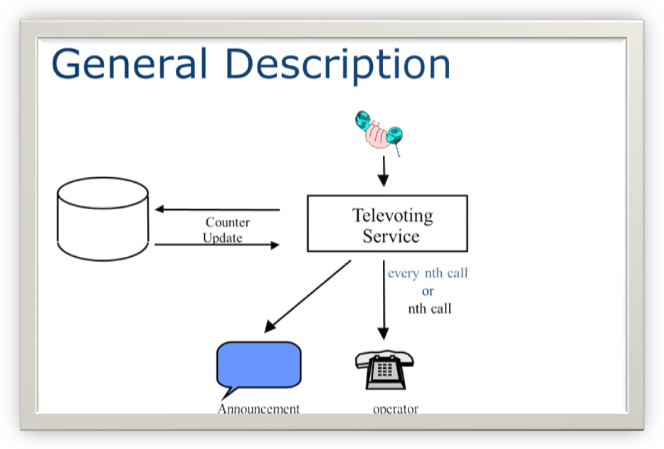
• Televoting is unique service used in collecting public opinion.
• A user who wishes to vote, can dial the specific voting number to register his vote of choice.
• Televoting is possible from STD barred phones also.
• Televoting is a more cost-effective method of democratic deliberation as it does not require the participants/voter to meet in person.
• Televoting numbers are 13 digit number :
• 1803-424-ABCD-XY (no charge to voter, service subscriber to pay)
• 1861-424-ABCD-XY (unit pulse charge to voter)
• 1862-424-ABCD-XY (two pulse charge to voter)
Who can subscribe for Televoting service?
• Media like TV and Press.
• Policy making bodies, political party/activities
• Quiz shows, contests, events, product choices, concepts, programmes, song and beauty contests etc.
What BSNL Offers to Televoting subscribers?
• For each completed call to the dialed VOT number, the chosen vote number increases a counter related to that choice.
• Validity Period/Time band for allowing voting
• Partial results can be given to the service subscriber while Televoting is in progress, if desired.
• Online viewing of results possible at customer premises
• Specified nth winner's call routing possible to a number in studio
• Service Provider (Subscriber) control of activation/ deactivation possible
• Certain telephone numbers may be put in Black List/ Grey list
• Origin Dependent Handling
• Revenue sharing between the service provider(Subscribers) & network provider (BSNL).

Universal Personal Number(UPN)

What is Universal Personal Number(UPN) Service?
By dialing the UPN number a service subscriber can be reached in the telephone network nationwide. He can also make calls using his Universal Personal Number from any BSNL Landline, but he will be billed on his UPN. All the calls made by subscriber using his UPN will be billed at his UPN by the IN Platform. The subscriber will be given a management code and password using which he can designate any BSNL/MTNL phone/mobile on which hisUPN Calls can be sent by the IN System. This service has the potential to shift calls from mobiles (of other operators) to landline of BSNL.
What are its advantages?
It is convenient for the user who is mobile between offices or different cities but do not want all calls to come on his mobile. The subscriber can retain the UPN number even after the office location changes. Thus this service can be positioned between landline and mobile. Since mobile number has become a very personal number; Senior, Middle management and specially women workers may be reluctant to reveal their mobile no UPN takes advantage of this fact as call coming on UPN can be mapped on any landline or mobile based on his/her convenience. Thus they can avoid giving mobile phone number to everyone.
How this service is used?
After you subscribe to this service you shall be given a logical number 1868 SCP ABCD, which shall be called your UPN number. (SCP- 345/ 233/ 180/ 425 depending upon the location from where you apply for the service). With a management code 1808 SCP you may convert any roaming BSNL phone into your Universal Personal Number and change your PIN.
What are the advantages of UPN Service vis-a-vis mobile number?
UPN Number service is a service which fills the gap between landline and mobile. While landline is totally fixed while on the other side mobile number becomes a very personal number and every caller disturbs the holder. The UPN Service will allow the user more freedom, wherein he can decide when the call should reach his mobile or when the call should reach his land line or his PA’s landline/ mobile. With UPN number one need not write Office/residence & mobile number on the visiting cards and mobile number can be revealed only to few selected people.
What is the dialling plan of UPN Service?
To call a UPN Subscriber only the logical number needs to be dialed just like any dictionary number. e.g If UPN Number 1868-345-1000 is allotted to a customer having DEL Number 011-2222-1234 then any user who wants to reach this person will dial 1868 345 1000 only, the call will land on 011-2222-1234 and charge will be as per charging plan.
What can be done using Management Menu?
Management of UPN can be done by dialing management SAC 1808-345. On getting announcement “Pl. dial your UPN no.” the last 4 digits of UPN no. (1000 in this case) is to be dialed. On getting announcement “Pl. dial your PIN”, PIN 1234 (assumed PIN) is to be dialed.
Following Menu options are there:
1) “Dial 1 to register a new default destination”
2) “Dial 2 to deregister default destination”
3) “Dial 3 to modify your PIN”
4) “Dial 4 to make a outgoing call”
7. How a new number can be registered as new destination?
This feature is used to define a new number where UPN calls are to be routed. In the above case, when calls for UPN no. 1868 345 1000 are to be routed from no.
011-2222-1234 to 011-2337-2424, digit 1 is to be dialed followed by 2337-2424( without STD code) as new destination no. But when destination no is 080-2448-4845 (other SSA no.) then 080-2448-4845 (with STD code) is to be dialed.
How to register and deregister to new default destination?
In the above case if the UPN user wants to revert back routing of UPN calls to original 011-2222-1234, then (through option 2 of main menu) this feature can be used.
How the PIN can be modified?
PIN (4 digits) for UPN management can be modified through option 3 from the main menu. The subscriber is requested to change the PIN after every few weeks.
How to make outgoing call through UPN?
Option 4 from the main menu can be used for making outgoing calls through UPN.
What is the tariff for UPN?
To know the latest UPN tariff please visit BSNL website http://www.bsnl.co.in/index.html

FAQ For Universal Personal Number (UPN)
1. What is Universal Personal Number (UPN) Service?
By dialing the UPN number a service subscriber can be reached in the telephone network (BSNL/ MTNL) nationwide. He can also make calls using his Universal Personal Number from any BSNL Landline, but he will be billed on his UPN. All the calls made by subscriber using his UPN will be billed at his UPN by the IN platform. The subscriber will be given a management code and password using which he can designate any BSNL/MTNL phone/mobile on which his UPN Calls can be sent by the IN System. This service has the potential to shift calls from mobiles (of other operators) to landline of BSNL.
2. What are its advantages?
It is convenient for the user who is mobile between offices or different cities butdo not want all calls to come on his mobile. The subscriber can retain the UPN number even after the office location changes. Thus this service can be positioned between landline and mobile. Since mobile number has become a very personal number; Senior, Middle management and specially women workers may be reluctant to reveal their mobile no. UPN takes advantage of this fact as call coming on UPN can be mapped on any landline or mobile based on his/her convenience. Thus they can avoid giving mobile phone number to everyone.
3. How this service is used?
After you subscribe to this service you shall be given a logical number 1868 SCP ABCD, which shall be called your UPN number.(SCP- 345/ 233/ 180/ 425 depending upon the location from where you apply for the service). With a management code 1808 SCP you may convert any roaming BSNL phone into your Universal Personal Number and change your PIN.
4. What are the advantages of UPN Service vis-a-vis mobile number?
UPN Number service is a service which fills the gap between landline and mobile. While landline is totally fixed while on the other side mobile number becomes a very personal number and every caller disturbs the holder. The UPN Service will allow the user more freedom, wherein he can decide when the call should reach his mobile or when the call should reach his land line or his PA’s landline/ mobile. With UPN number one need not write Office/residence & mobile number on the visiting cards and mobile number can be revealed only to few selected people.
5. What is the dialing plan of UPN Service?
To call a UPN Subscriber only the logical number needs to be dialed just like any dictionary number. e.g If UPN Number 1868-345-1000 is allotted to a customer having DEL Number 011-2222-1234 then any user who wants to reach this person will dial 1868 345 1000 only, the call will land on 011-2222-1234 and charge will be as per charging plan.
6. What can be done using Management Menu?
Management of UPN can be done by dialing management SAC 1808-345. On getting announcement “Pl. dial your UPN no.” the last 4 digits of UPN no. (1000 in this case) is to be dialed. On getting announcement “Pl. dial your PIN”, PIN 1234 (assumed PIN) is to be dialed. Following Menu options are there:
1) “Dial 1 to register a new default destination”
2) “Dial 2 to deregister default destination”
3) “Dial 3 to modify your PIN”
4) “Dial 4 to make a outgoing call”
7. How a new number can be registered as new destination?
This feature is used to define a new number where UPN calls are to be routed. In the above case, when calls for UPN no. 1868 345 1000 are to be routed from no. 011-2222-1234 to 011-2337-2424, digit 1 is to be dialed followed by 2337-2424( without STD code) as new destination no. But when destination no is 080-2448-4845 (other SSA no.) then 080-2448-4845 (with STD code) is to be dialed.
8. How to register and deregister to new default destination?
In the above case if the UPN user wants to revert back routing of UPN calls to original 011-2222-1234, then (through option 2 of main menu) this feature can be used.
9. How the PIN can be modified?
PIN (4 digits) for UPN management can be modified through option 3 from the main menu. The subscriber is requested to change the PIN after every few weeks.
10. How to make outgoing call through UPN?
Option 4 from the main menu can be used for making outgoing calls through
UPN.
1. What is the tariff for UPN?
To know the latest UPN tariff please visit BSNL website http://www.bsnl.co.in/index.html

Account Calling Card (ACC)
Account Card Calling:
This service allows the user to make a phone call from any normal phone to any destination number and have the cost of these calls charged to the account specified by the Account calling card. This card is ideal for corporate and executives. Economical and convenient, customer need not worry about consumption out of budget and helps executives control their calling. It can be availed from BSNL offices.
Features:
- Four simultaneous calls possible from same Account Card
- Local, National and International dialing possible.
- National, International call restriction.
- Call restriction also possible according to origin & destination
- Multiple Language choices
- Detailed bill facility available on demand at cost.
- Account balance announcement with Real Time Credit Supervision
- Minimum credit to use the service with Warning Tone when credit reaches optimum level
- Follow On Calling – In case of Called Party On Hook, Called Party No Reply & Called Party Busy, the user can make a second call without entering the secret code number
- Provider Incoming /Outgoing Black List

Premium Rate Service(PRM)
In an information society acquisition of plentiful information affects our life greatly. From daily life to financial investment from shopping to traveling. The PRM service enables service subscribers to provide such information at a premium calling rate to users. For users it is a quick and accurate way to get the latest information - anytime…anywhere.
The service subscriber can be reached through a PRM number and all calls are routed to the destination he registered. The service subscriber may have incoming calls routed to his installation or rejected according to a set of features.
PRM Service can be accessed with code 1867-xyz (xyz : 233, 345, 180, 425). Presently this service is only accessible from Prepaid GSM network of BSNL.
Features:
- Revenue sharing between the service provider & network provider (BSNL).
- PRM service accessible through prepaid mobile of BSNL.
- Service is made available from Telephones who wish to avail this service.
- For other features refer the features of TFS and UAN.

Virtual Calling Card (VCC)
This convenient prepaid card gives the customer the freedom to make local, STD, or ISD calls even from a STD or ISD barred phone. Simply the customer can dial the access code and 16 digit secret code from any telephone set, nearby, to make calls without paying the call fee on site.
India Telephone cards are available at all customer service centers of BSNL and its franchises, ITC card purchased in one city can be used in any other city. Some ITC meant to be used in particular area viz. J&K will be printed with such message and can only be used in that area.
Features:
- ITC cards available in various denominations to suit a customer’s need & pocket.
- No registration charges
- Expiry period 18 months from the date of printing and validity period of 3 - 9 months to suit the customer convenience and usage.
- Multiple Language Choices
- Detailed bill facility available on demand, at cost.
- Account balance announcement with Real Time Credit Supervision
- Minimum credit to use the service with Warning Tone when credit reaches optimum level
- Follow On Calling – In case of Called Party On Hook, Called Party No Reply & Called Party Busy, the user can go and make a second call without entering the secret code number
- Provider Incoming /Outgoing Black List
- ITC cards can be used to make PRM calls
- ITC cards can be used to make calls from BSNL mobiles
- ‘Cards under ‘CallNow’ brand are ITC with cheaper STD/ISD charges but costlier local call charges for BSNL to BSNL/other operators compared to normal ITC and normal BSNL land line call charges
- Access code: 1802-XYZ (XYZ given on ITC card ).

- On 10th July’ 2010 a new VCC card ”Universal ITC” was launched with per second Billing.

Fixed Line prepaid(flpp)
FAQs on FLPP
What is FLPP(Fixed Line Prepaid) service of BSNL?
FLPP Service enables a subscriber to make calls from a prepaid account linked to his telephone number. Unlike the prepaid card ‘ITC’ service, where the authentication is done every time through a 16-digit PIN the authentication of FLPP is linked to his telephone line & the user is not required to dial the Account number/ PIN for authentication making it simpler to use.
What are the features of FLPP service?
Fixed Line Prepaid service offers Conversion of fixed line to Pre Paid (get rid of telephone bills), Easy de-linking from telephone line when prepaid is not required on any number, No need to dial Account number/ PIN every time you make a call, STD/ISD Facility, On Line balance enquiry, ‘Follow on feature’ on no reply, busy and called party release to dial another number for subscribers other than PCO, Easy recharge and no problem of bills, Free Level 1 service like 100, 101, 102 etc. available, Free Level 1 IN services which are free to end-customers like Free Phone etc. are available
How many types of FLPP Accounts are there?
There can be four types of FLPP accounts namely - PCO FLPP Account, PCO Local FLPP Account, General FLPP Prepaid Account and General FLPP Prepaid + Post paid Account. However please check from BSNL website or nearest BSNL office or BSNL help desk as to which type of services are in operation at present.
Which type of Account card should I purchase?
You should purchase Account card based on your type of line i.e. PCO or general line. In case of General user you should purchase Account card based on your requirement i.e. fully prepaid or Prepaid + Post paid?

How many type of Recharge coupons are there?
There will be two types of Recharge coupons one for PCO (same for both type of accounts) and one for General user (same for both type of accounts).
Which type of Recharge coupon should I purchase?
You should purchase recharge coupon as per your Account profile only. It is mentioned on the Recharge coupon as to which type of Account cards can be recharged using the recharge coupon.
Can FLLP service be accessed only from Fixed Line?
FLPP service can be accessed from Fixed Line as well as WLL networks. However BSNL will announce from time to time the type of exchanges from where this service shall be available. Presently it is available from OCB-283, AXE-10, EWSD, 5ESS and E10B type of exchanges.
How shall I access my account for the first time? Or How can I attach my line to my account?
The first time dialing procedure is dependent on type of account card and is as follows: (i) FLPP PCO Account or FLPP Local PCO Account- dial ‘1284#’ and follow announcement or use remote access i.e. dial 1806 345 (for East & North zone and 1806 233 for west & south zone account cards) from PCO and follow announcement to attach your line (CLI) to your account. (ii) FLPP General Account Pure prepaid - dial ‘1284#’ and follow announcement or use remote access i.e. dial 1806 345 (for East and North zone and 1806 233 for west & South zone account cards) and follow announcement to attach your line (CLI) to your account. (iii) FLPP General account Post paid + Pre Paid - use remote access i.e. dial 1806 345 (for East & North zone and 1806 233 for west & south zone account cards), after which you will be prompted for Account number –dial account number. Then you will be prompted to dial the PIN – dial the PIN. Then you will be asked to dial destination number – dial destination number followed by hash or dial 9 followed by hash to access main menu. Dial service number 4 to attach your line, dial ‘1’ to continue.
What are different dialing procedures?
Direct access - Dial destination number directly. Authentication is automatic. You can make calls only from the telephone number whose (line) CLI has been attached to the account. Your telephone line is configured at the local exchange for this purpose. This can be used by PCO owners and by General FLPP Pure paid users. (2)Remote access - FLPP account can be used from any telephone line. To use this service dial 1806 345 (for East & North zone and 1806 233 for West & South zone account cards), after which you will be prompted for Account number –dial account number. Then you will be prompted to dial the PIN –dial the PIN. Then you will be asked to dial destination number – dial destination number followed by hash or dial 9 followed by hash to access main menu. Dial service number 4 to attach your line, dial ‘1’ to continue. It may be used by PCO owners and General FLPP Pure Pre Paid accounts for the first time use. General FLPP accounts post paid + Pre paid can use remote access to attach/detach their line and to make calls from other lines. (3) Express access –Dial 1805 345 (for East & North zone and 1805 233 for West & South zone account cards) followed by destination number. No need to dial account number & PIN authentication. For this purpose attach your telephone line to the account using the menu management feature. It will be used by General FLPP post paid + pre paid Account holder to make calls from its attached line.

What can I do with Menu Management options?
You can change your PIN, enable/disable PIN, attach or detach your line (CLI), select languages, know your credit in the Account, recharge your account etc.
How can I access the Menu?
You can access the menu in two ways: (1) FLPP PCO Account, FLPP Local PCO Account and FLPP General Pure Prepaid Accounts – You need to dial 1284# to access the menu. (2)FLPP General ‘Prepaid+Post paid’ Accounts - In this case to access the menu you will have to dial the remote login code 1806 345 (for East & North zone and 1806 233 for West & South zone account card) and follow announcement for menu management.
What are the various Menu Management options?
The menu is operated by dialing service option for various purposes as follows: (i) For language modification dial ‘0’ (ii) For PIN Management dial 1 (Then in sub menu dial 1 to change the PIN and 2 to enable or disable PIN) (iii) For Recharge dial 2 (iv) To know your account balance, dial 3. (v) For account attachment/detachment dial 4 (vi) For Help dial 5. (vii) For Remote access enable/disable dial 6 (viii) For redial dial 7.
What features will FLPP service provides me if I am a PCO Owner?
FLPP Service will provide following features to a PCO owner: Offers convenience of not paying the bills, The prepaid account will be directly linked to the PCO’s telephone line, The customer line shall be suitably configured from the local exchange so that you can dial the destination number by lifting the phone, Home metering shall be provided so that you can charge your customer., Remote login facility is provided only to attach/detach line. PIN option can be enabled for fraud control purpose only. PIN is not mandatory to access menu, PIN can be enabled only to prevent fraud from direct line., Menu management shall be provided through access code of ‘1284#’, Only PCO line can be attached to FLPP account, Only one call possible from the account at a time.
Is FLPP service different for Local and STD PCO?
There can be two types of PCO accounts – FLPP PCO Account - offering Prepaid services (for Local +STD+ISD) & FLPP PCO Local Account - offering Prepaid services (for local calls only). All other features will be same for both type of accounts. However the customer needs to check with the local office whether both the services are available at present.
What features will FLPP service provides me if I am not a PCO owner but a FLPP General Account holder?
FLPP General Accounts can be of two types – FLPP General Pure Prepaid – offers only Prepaid Services and FLPP General ‘Prepaid+Postpaid’ – offers both prepaid as well as postpaid services. Common features of both are as follows : Remote login facility is available, Redial & Follow-on facilities are available, This service can be provided to all wire-line customers other than PCOs i.e. to both residential as well as commercial customers.
What features will FLPP service provide me if I am a FLPP General Pure Prepaid customer?
Features specific to only Prepaid services are as follows : The customer can make only prepaid calls through his FLPP Account, The customer line will be configured from the exchange. The customer dials the desired number directly and the call is credited to his FLPP account, PIN option shall be available to attach/ detach account with particular line (CLI) and other menu management options & if PIN option is enabled for control purpose also it will be mandatory to dial the PIN every time before ialing the destination no.
What features will FLPP service provide me if I am a FLPP General ‘Prepaid+Postpaid’ customer?
Features specific to accounts having ‘Prepaid+Postpaid’ are as follows: The customer has the option of making both prepaid calls through his FLPP account as well as postpaid calls. The customer is required to dial 1805 345 (for East & North zone and 1805 233 for West & South zone account card) followed by destination number for making prepaid calls. Postpaid calls can be made directly. No configuration required to be done at the local exchange for the telephone line. PIN option shall be available to attach/ detach account with particular line (CLI) and other menu management options.
How can I get my account activated?
First the account should be attached to the line in case of the PCO account or FLPP General Pure Prepaid account. There is no need of line attachment in case of General FLPP Prepaid+postpaid account. Your Account will get activated with the first outgoing call.
In which language shall I get the announcements?
For choice of language of announcements the selection can be made at the time of first call or a default Language shall be attached to the account profile.
What steps can I take if my account card is lost?
You must keep your account card very carefully. If it is lost/stolen/misplaced, it cannot be deactivated and therefore may be misused. You will then lose out on any credit remaining in your card. In this case BSNL will not be in a position to take any action, or be liable for any refunds.
Is there a provision to carry forward the balance?
You can carry over the remaining balance and time of your card to next cycle, if you recharge within Grace period.
What will happen if I do not recharge my account within validity period and Grace period?
‘PCO FLPP account’ or ‘General FLPP Pure Prepaid’ - If you don’t get your recharge within your validity period, your account will become inactive. In this state you cannot make outgoing calls however you will continue to get incoming calls within the Grace period. After Grace period your account will expire and you will not be able to recharge and your telephone line will be disconnected. In such a case you need to buy a new Account and get your telephone line reconnected. General FLPP ‘Prepaid+Postpaid’ – If you do not recharge within your validity period, your account will become inactive. After the grace period your account will expire and you will not be able to recharge. However you can make calls using postpaid option and you will continue to get incoming calls. You will have to procure another account card for using the prepaid option.
How do I know as to when the validity/ inactivity period will expire?
Warning announcement shall be provided few days ahead of end of validity period, end of inactivity period.
How do I know that my balance is going to finish?
A query can be placed using Menu management to find out the balance. A voice announcement/tone will remind you to recharge your account every time you make a call, once your balance reaches less than a threshold.
How can I recharge my BSNL FIXED LINE PRE-PAID ACCOUNT CARD?
To recharge your account scratch the recharge coupon and obtain the 16 digits code. Dial 1805 345 1284 from ‘postpaid+prepaid’ account or just 1284 from pure prepaid or PCO account. Follow the announcement.
What if I dial the PIN wrongly repeatedly for recharge purpose?
Your account will be blocked if you dial the PIN wrongly more than three times. In this scenario you may contact help desk at 1-800-345-1800 for unblocking the card.
Whom I can contact in case of difficulty?
Please dial Toll free number 1-800-345- 1800 to reach Help Desk executive.
What precautions I should take while purchasing FLPP Account card?
Please check whether the service is available in your exchange area and see that the account card is unscratched.
What precautions I should take while purchasing FLPP recharge coupons?
Match your FLPP Account card profile with that of recharge coupon and ensure that it is unscratched.
What are the features of FLPP service?
Fixed Line Prepaid service offers Conversion of fixed line to Pre Paid (get rid of telephone bills), Easy de-linking from telephone line when prepaid is not required on any number, No need to dial Account number/ PIN every time you make a call, STD/ISD Facility, On Line balance enquiry, ‘Follow on feature’ on no reply, busy and called party release to dial another number for subscribers other than PCO, Easy recharge and no problem of bills, Free Level 1 service like 100, 101, 102 etc. available, Free Level 1 IN services which are free to end-customers like Free Phone etc. are available
How many types of FLPP Accounts are there?
There can be four types of FLPP accounts namely - PCO FLPP Account, PCO Local FLPP Account, General FLPP Prepaid Account and General FLPP Prepaid + Post paid Account. However please check from BSNL website or nearest BSNL office or BSNL help desk as to which type of services are in operation at present.
Which type of Account card should I purchase?
You should purchase Account card based on your type of line i.e. PCO or general line. In case of General user you should purchase Account card based on your requirement i.e. fully prepaid or Prepaid + Post paid?
How many type of Recharge coupons are there?
There will be two types of Recharge coupons one for PCO (same for both type of accounts) and one for General user (same for both type of accounts).
Which type of Recharge coupon should I purchase?
You should purchase recharge coupon as per your Account profile only. It is mentioned on the Recharge coupon as to which type of Account cards can be recharged using the recharge coupon.
Can FLLP service be accessed only from Fixed Line?
FLPP service can be accessed from Fixed Line as well as WLL networks. However BSNL will announce from time to time the type of exchanges from where this service shall be available. Presently it is available from OCB-283, AXE-10, EWSD, 5ESS and E10B type of exchanges.
How shall I access my account for the first time? Or How can I attach my line to my account?
The first time dialing procedure is dependent on type of account card and is as follows: (i) FLPP PCO Account or FLPP Local PCO Account- dial ‘1284#’ and follow announcement or use remote access i.e. dial 1806 345 (for East & North zone and 1806 233 for west & south zone account cards) from PCO and follow announcement to attach your line (CLI) to your account. (ii) FLPP General Account Pure prepaid - dial ‘1284#’ and follow announcement or use remote access i.e. dial 1806 345 (for East and North zone and 1806 233 for west & South zone account cards) and follow announcement to attach your line (CLI) to your account. (iii) FLPP General account Post paid + Pre Paid - use remote access i.e. dial 1806 345 (for East & North zone and 1806 233 for west & south zone account cards), after which you will be prompted for Account number –dial account number. Then you will be prompted to dial the PIN – dial the PIN. Then you will be asked to dial destination number – dial destination number followed by hash or dial 9 followed by hash to access main menu. Dial service number 4 to attach your line, dial ‘1’ to continue.
What are different dialing procedures?
Direct access - Dial destination number directly. Authentication is automatic. You can make calls only from the telephone number whose (line) CLI has been attached to the account. Your telephone line is configured at the local exchange for this purpose. This can be used by PCO owners and by General FLPP Pure paid users. (2)Remote access - FLPP account can be used from any telephone line. To use this service dial 1806 345 (for East & North zone and 1806 233 for West & South zone account cards), after which you will be prompted for Account number –dial account number. Then you will be prompted to dial the PIN –dial the PIN. Then you will be asked to dial destination number – dial destination number followed by hash or dial 9 followed by hash to access main menu. Dial service number 4 to attach your line, dial ‘1’ to continue. It may be used by PCO owners and General FLPP Pure Pre Paid accounts for the first time use. General FLPP accounts post paid + Pre paid can use remote access to attach/detach their line and to make calls from other lines. (3) Express access –Dial 1805 345 (for East & North zone and 1805 233 for West & South zone account cards) followed by destination number. No need to dial account number & PIN authentication. For this purpose attach your telephone line to the account using the menu management feature. It will be used by General FLPP post paid + pre paid Account holder to make calls from its attached line.
What can I do with Menu Management options?
You can change your PIN, enable/disable PIN, attach or detach your line (CLI), select languages, know your credit in the Account, recharge your account etc.
How can I access the Menu?
You can access the menu in two ways: (1) FLPP PCO Account, FLPP Local PCO Account and FLPP General Pure Prepaid Accounts – You need to dial 1284# to access the menu. (2)FLPP General ‘Prepaid+Post paid’ Accounts - In this case to access the menu you will have to dial the remote login code 1806 345 (for East & North zone and 1806 233 for West & South zone account card) and follow announcement for menu management.
What are the various Menu Management options?
The menu is operated by dialing service option for various purposes as follows: (i) For language modification dial ‘0’ (ii) For PIN Management dial 1 (Then in sub menu dial 1 to change the PIN and 2 to enable or disable PIN) (iii) For Recharge dial 2 (iv) To know your account balance, dial 3. (v) For account attachment/detachment dial 4 (vi) For Help dial 5. (vii) For Remote access enable/disable dial 6 (viii) For redial dial 7.
What features will FLPP service provides me if I am a PCO Owner?
FLPP Service will provide following features to a PCO owner: Offers convenience of not paying the bills, The prepaid account will be directly linked to the PCO’s telephone line, The customer line shall be suitably configured from the local exchange so that you can dial the destination number by lifting the phone, Home metering shall be provided so that you can charge your customer., Remote login facility is provided only to attach/detach line. PIN option can be enabled for fraud control purpose only. PIN is not mandatory to access menu, PIN can be enabled only to prevent fraud from direct line., Menu management shall be provided through access code of ‘1284#’, Only PCO line can be attached to FLPP account, Only one call possible from the account at a time.
Is FLPP service different for Local and STD PCO?
There can be two types of PCO accounts – FLPP PCO Account - offering Prepaid services (for Local +STD+ISD) & FLPP PCO Local Account - offering Prepaid services (for local calls only). All other features will be same for both type of accounts. However the customer needs to check with the local office whether both the services are available at present.
What features will FLPP service provides me if I am not a PCO owner but a FLPP General Account holder?
FLPP General Accounts can be of two types – FLPP General Pure Prepaid – offers only Prepaid Services and FLPP General ‘Prepaid+Postpaid’ – offers both prepaid as well as postpaid services. Common features of both are as follows : Remote login facility is available, Redial & Follow-on facilities are available, This service can be provided to all wire-line customers other than PCOs i.e. to both residential as well as commercial customers.
What features will FLPP service provide me if I am a FLPP General Pure Prepaid customer?
Features specific to only Prepaid services are as follows : The customer can make only prepaid calls through his FLPP Account, The customer line will be configured from the exchange. The customer dials the desired number directly and the call is credited to his FLPP account, PIN option shall be available to attach/ detach account with particular line (CLI) and other menu management options & if PIN option is enabled for control purpose also it will be mandatory to dial the PIN every time before ialing the destination no.
What features will FLPP service provide me if I am a FLPP General ‘Prepaid+Postpaid’ customer?
Features specific to accounts having ‘Prepaid+Postpaid’ are as follows: The customer has the option of making both prepaid calls through his FLPP account as well as postpaid calls. The customer is required to dial 1805 345 (for East & North zone and 1805 233 for West & South zone account card) followed by destination number for making prepaid calls. Postpaid calls can be made directly. No configuration required to be done at the local exchange for the telephone line. PIN option shall be available to attach/ detach account with particular line (CLI) and other menu management options.
How can I get my account activated?
First the account should be attached to the line in case of the PCO account or FLPP General Pure Prepaid account. There is no need of line attachment in case of General FLPP Prepaid+postpaid account. Your Account will get activated with the first outgoing call.
In which language shall I get the announcements?
For choice of language of announcements the selection can be made at the time of first call or a default Language shall be attached to the account profile.
What steps can I take if my account card is lost?
You must keep your account card very carefully. If it is lost/stolen/misplaced, it cannot be deactivated and therefore may be misused. You will then lose out on any credit remaining in your card. In this case BSNL will not be in a position to take any action, or be liable for any refunds
Is there a provision to carry forward the balance?
You can carry over the remaining balance and time of your card to next cycle, if you recharge within Grace period.
What will happen if I do not recharge my account within validity period and Grace period?
‘PCO FLPP account’ or ‘General FLPP Pure Prepaid’ - If you don’t get your recharge within your validity period, your account will become inactive. In this state you cannot make outgoing calls however you will continue to get incoming calls within the Grace period. After Grace period your account will expire and you will not be able to recharge and your telephone line will be disconnected. In such a case you need to buy a new Account and get your telephone line reconnected. General FLPP ‘Prepaid+Postpaid’ – If you do not recharge within your validity period, your account will become inactive. After the grace period your account will expire and you will not be able to recharge. However you can make calls using postpaid option and you will continue to get incoming calls. You will have to procure another account card for using the prepaid option.
How do I know as to when the validity/ inactivity period will expire?
Warning announcement shall be provided few days ahead of end of validity period, end of inactivity period.
How do I know that my balance is going to finish?
A query can be placed using Menu management to find out the balance. A voice announcement/tone will remind you to recharge your account every time you make a call, once your balance reaches less than a threshold.
How can I recharge my BSNL FIXED LINE PRE-PAID ACCOUNT CARD?
To recharge your account scratch the recharge coupon and obtain the 16 digits code. Dial 1805 345 1284 from ‘postpaid+prepaid’ account or just 1284 from pure prepaid or PCO account. Follow the announcement.
What if I dial the PIN wrongly repeatedly for recharge purpose?
Your account will be blocked if you dial the PIN wrongly more than three times. In this scenario you may contact help desk at 1-800-345-1800 for unblocking the card.
Whom I can contact in case of difficulty?
Please dial Toll free number 1-800-345- 1800 to reach Help Desk executive.
What precautions I should take while purchasing FLPP Account card?
Please check whether the service is available in your exchange area and see that the account card is unscratched.
What precautions I should take while purchasing FLPP recharge coupons?
Match your FLPP Account card profile with that of recharge coupon and ensure that it is unscratched.
Who to use ITC card-
bpaidtthe Simply the customer can dial the access code and 16 digit secret code from any telephone set, nearby, to make calls without paying the call fee on site.
India Telephone cards are available at all customer service centers of BSNL and its franchises, ITC card purchased in one city can be used in any other city. Some ITC meant to be used in particular area viz. J&K will be printed with such message and can only be used in that area.
Features:
- ITC cards available in various denominations to suit a customer’s need & pocket.
- No free calls, all calls are chargeable @ Rs.1.00 per unit for calls originating from PSTN and @ Rs.1.20 per unit for calls originating from mobiles.
- No registration charges
- Expiry period 18 months from the date of printing and validity period of 3 - 9 months to suit the customer convenience and usage.
- Multiple Language Choices
- Detailed bill facility available on demand, at cost.
- Account balance announcement with Real Time Credit Supervision
- Minimum credit to use the service with Warning Tone when credit reaches optimum level
- Follow On Calling – In case of Called Party On Hook, Called Party No Reply & Called Party Busy, the user can go and make a second call without entering the secret code number
- Provider Incoming /Outgoing Black List
- ITC cards can be used to make PRM calls
- ITC cards can be used to make calls from BSNL mobiles
- ‘Cards under ‘CallNow’ brand are ITC with cheaper STD/ISD charges but costlier local call charges for BSNL to BSNL/other operators compared to normal ITC and normal BSNL land line call charges
Activation and Tariff:
Card is activated on first use or on checking the balance.
All calls are preceded by the code 1802 XYZ (XYZ = 345/425/180/233)
Applicable service tax included in cost of card.
Cards available in various denomination of Rs. 50, Rs. 100, Rs. 200, Rs.500, Rs.1000, Rs. 2000, Rs.5000/-
‘’CallNow’ cards available in Rs. 100, Rs.300, Rs.500, Rs.1000, Rs. 2000.
Volume based discount on sale of cards and PINs to BSNL Franchisees.
Electronic PINs available for sale for different denominations in addition to cards
For latest update please visit BSNL website http://.www.bsnl.co.in.

Access Codes for Different IN Services

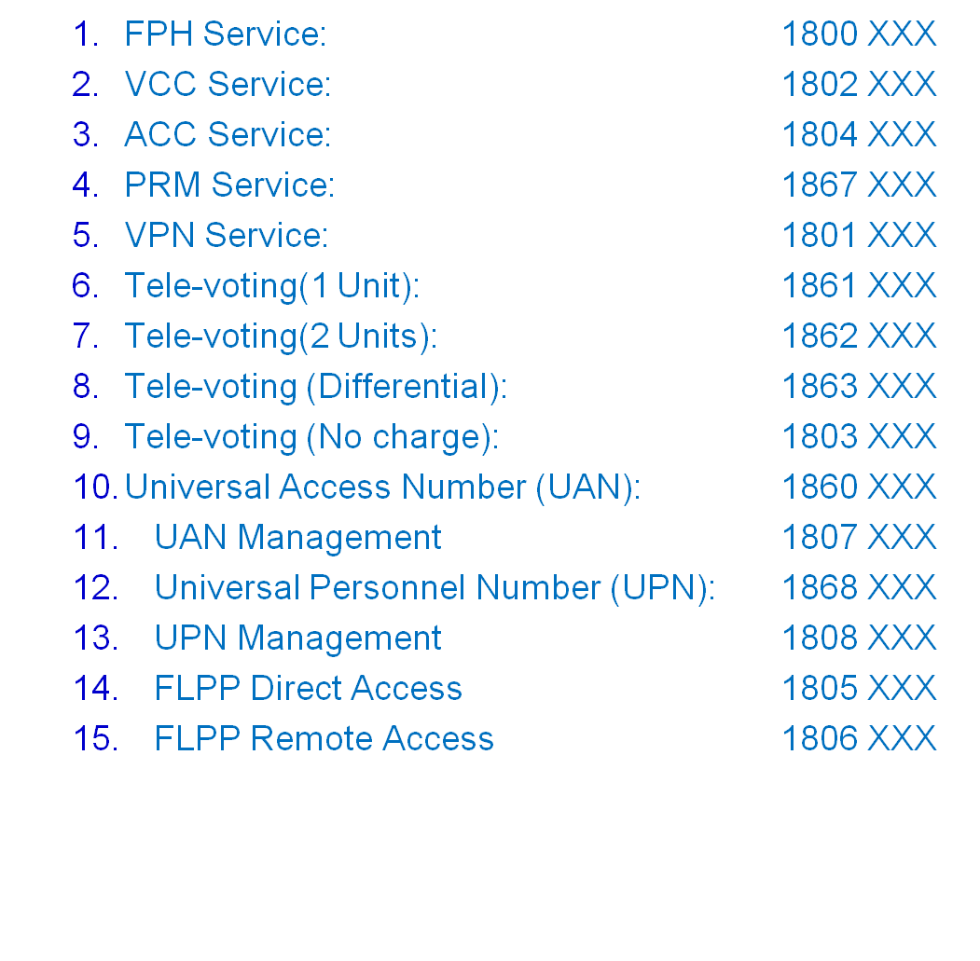
SCP Codes:
Lucknow: 180 Bangalore: 425
Ahmedabad: 233 Hyderabad: 424 and 888 Kolkata: 345

